^{SVKM’s NMIMS}
Mukesh Patel School of Technology Management and Engineering
BTech Computer Science and Engineering (Data Science)

^{-311 Program Semester – IV}

Academic Year 2024-25
Plagiarism Detection Software

Report by
L004 – Ishaa Bhalekar
L005 – Arpita Das

^{Faculty In charge}
^{Prof. Sofia Francis}

Introduction
Problem Statement
Scope and Societal Need
List of Functions
Architecture
Algorithmic Steps for Each Method
1. Longest Common Subsequence (LCS)
2. getNGrams
3. Merge Sort
4. matchedNGrams
5. loadSynonyms
6. cleanWord
7. suggestWordsToChange
Data Structures Implemented
Flowchart
Sequence diagram
Code in C++
Output Screenshot
Time and Space Complexity Analysis
Limitations
Scope of Improvement

Introduction
Plagiarism refers to the act of presenting someone else's work or ideas as your own without proper acknowledgment. In academic, research, and professional writing, it’s crucial to maintain originality and give due credit. Our project aims to design a C++-based plagiarism detection tool that identifies both exact and paraphrased copies of text using optimized algorithms and data structures.

Problem Statement
- With the rise of digital content, detecting plagiarism has become a major challenge in both academic and professional domains. Traditional methods often miss paraphrasing, word rearrangements, and synonym usage.

- Our goal is to develop a C++-based plagiarism detection system that uses LCS, N-Grams, and synonym analysis to identify similar content—even when rephrased—with high accuracy. After calculating the plagiarism percentage, the system highlights matched phrases and provides intelligent synonym suggestions to help users rephrase their content and reduce similarity, promoting original writing.

Scope and Societal Need
This tool can be used:
- In academic institutions to verify student submissions.
- By researchers and publishers to ensure originality.
- For detecting duplicate content in articles and blogs.

As digital content creation grows, such tools will help maintain integrity and quality across industries.

List of Functions
- tokenize(): Separates words for processing.
- longestCommonSubsequence(): Finds similar sequences.
- getNGrams(): Creates sliding window phrases.
- mergeSort(): Sorts frequent n-grams or matches.
- matchedNGrams(): Identifies overlapping phrases.
- loadSynonyms(): Loads word-alternatives.
- suggestWordsToChange(): Offers replacement suggestions.

Architecture

The code follows a modular architecture with distinct components:

Input Processing: Reads original text from "Dataset.txt" and user input from console

Text Analysis: Processes texts using tokenization and similarity algorithms

Plagiarism Detection: Uses two methods (LCS and N-Grams) to identify similarities

Suggestion Generation: Identifies matching phrases and suggests synonyms

Output Generation: Displays similarity percentage and improvement suggestions
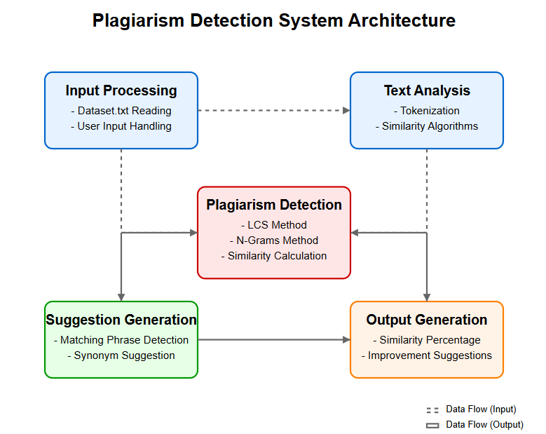

Our program implements a pipeline where text flows through these components sequentially, with each module taking the output of the previous one as input.

Algorithmic Steps for Each Method

Longest Common Subsequence (LCS)

Implements the LCS algorithm using dynamic programming to find the length of the longest sequence of words that appear in both texts in the same order. It creates a matrix where each cell represents the length of the LCS up to those positions. This function provides a measure of overall textual similarity.
Steps:
Input: Two tokenized lists of words: A[1..m] and B[1..n].
FUNCTION LongestCommonSubsequence(A[], B[]):
m = length of A
n = length of B
// Initialize DP table
DP[0...m][0...n] = 0
// Fill DP table
FOR i = 1 TO m:
FOR j = 1 TO n:
IF A[i-1] equals B[j-1]:
DP[i][j] = DP[i-1][j-1] + 1
ELSE:
DP[i][j] = MAX(DP[i-1][j], DP[i][j-1])
RETURN DP[m][n]

getNGrams

Creates "n-grams" (consecutive sequences of n words) from a tokenized text. For example, with n=2, "the quick brown fox" becomes ["the quick", "quick brown", "brown fox"]. N-grams capture phrases and word combinations, which are more distinctive than single words for detecting copied content.
Steps:
FUNCTION getNGrams(vector<string> tokens, integer n)
Create empty vector ngrams
IF length of tokens < n THEN
RETURN empty ngrams
END IF
FOR i = 0 to (tokens.size - n)
Set ngram string to empty
FOR j = 0 to (n-1)
Append tokens[i+j] to ngram
IF j < n-1 THEN
Append space to ngram
END IF
END FOR
Add ngram to ngrams vector
END FOR
RETURN ngrams
END FUNCTION

Merge Sort

Implementation of the merge sort algorithm specifically for sorting n-grams alphabetically. Sorting is necessary before comparison to efficiently find matching phrases between texts. The merge function combines two sorted subarrays, while mergeSort recursively divides and conquers the sorting problem.
Steps:
FUNCTION merge(vector<string> &arr, integer left, integer middle, integer right)
Set n1 = middle - left + 1
Set n2 = right - middle

Create vector L containing elements from arr[left] to arr[middle]
Create vector R containing elements from arr[middle+1] to arr[right]

Set i = 0, j = 0, k = left

WHILE i < n1 AND j < n2
IF L[i] <= R[j] THEN
arr[k] = L[i]
Increment i
ELSE
arr[k] = R[j]
Increment j
END IF
Increment k
END WHILE

WHILE i < n1
arr[k] = L[i]
Increment i and k
END WHILE

WHILE j < n2
arr[k] = R[j]
Increment j and k
END WHILE
END FUNCTION
FUNCTION mergeSort(vector<string> &arr, integer left, integer right)
IF left < right THEN
Set middle = left + (right - left)/2
Call mergeSort(arr, left, middle)
Call mergeSort(arr, middle+1, right)
Call merge(arr, left, middle, right)
END IF
END FUNCTION

matchedNGrams

Identifies which n-grams from the user's text also appear in the base text. It uses an unordered_set for efficient lookup to build a list of matching phrases, which are potential instances of copying.

Steps:
FUNCTION matchedNGrams(vector<string> base, vector<string> user)

Create unordered_set baseSet from base vector elements

Create empty vector matches

FOR each gram in user

IF gram exists in baseSet THEN

Add gram to matches

END IF

END FOR

RETURN matches

END FUNCTION

loadSynonyms

Reads a synonym dictionary file where each line contains a word followed by a colon and its synonyms. Creates a mapping from words to their possible replacements, which is used to suggest alternatives for plagiarized content.
Steps:

FUNCTION loadSynonyms(string filename)

Create empty unordered_map synonymsMap

Open file with filename

IF file failed to open THEN

Print error message

RETURN empty synonymsMap

END IF

FOR each line in file

Find position of colon in line

IF colon exists THEN

Extract word (before colon)

Remove trailing spaces from word

Extract synonyms string (after colon)

Create empty vector synonymsList

FOR each synonym word in synonyms string

Remove comma if present

Add to synonymsList

END FOR

Set synonymsMap[word] = synonymsList

END IF

END FOR

Close file

RETURN synonymsMap

END FUNCTION

cleanWord

Removes punctuation and extra spaces from words to improve matching accuracy when looking up synonyms. This ensures that words like "system," and "system" are treated as the same word.
Steps:

FUNCTION cleanWord(string word)

Set cleaned = word

FOR each character c in cleaned

IF c is punctuation THEN

Replace c with space

END IF

END FOR

Create stringstream from cleaned

Extract first word from stringstream to cleaned

RETURN cleaned

END FUNCTION

suggestWordsToChange
Identifies which words contribute most to the plagiarism detection by analyzing frequency. It finds words that appear in both texts, sorts them by frequency, and suggests replacements for the most common words. This targets high-impact changes to reduce plagiarism scores.
Steps:
FUNCTION suggestSynonymsForMatches(vector<string> matches, unordered_map synonymsMap)
Print header for synonym suggestions

FOR each match in matches
Print "For phrase: match"

Set words = tokenize(match)
Set hasSuggestions = false

FOR each word in words
Set cleanedWord = cleanWord(word)
Convert cleanedWord to lowercase

IF synonymsMap contains cleanedWord AND synonyms exist THEN
Set hasSuggestions = true
Print "Instead of word, consider: "

FOR each synonym in synonymsMap[cleanedWord]
Print synonym with appropriate separators
END FOR
END IF
END FOR

IF not hasSuggestions THEN
Print "No synonyms found for words in this phrase"
END IF
END FOR
END FUNCTION

Data Structures Implemented

- vector<string>: Used to store lists of words—like tokens after text is split, LCS results, generated n-grams, and synonym suggestions for output.

- string: Holds the full input text, individual tokens (words), and phrases during processing and comparison.

- unordered_set<string>: Helps quickly check for the presence of an n-gram or avoid duplicates. Offers constant-time lookup.

- unordered_map<string, vector<string>>: Represents a synonym dictionary, where each word maps to a list of its related synonyms.

- unordered_map<string, int>: Counts how often each word appears—useful for frequency analysis, keyword extraction, or filtering.

- unordered_map<string, string>: Stores the original case of words (e.g., “India” vs. “india”) to maintain proper formatting in the final output.

- pair<string, int>: Used to associate each word with its frequency, especially helpful for sorting and displaying results in order.

Flowchart
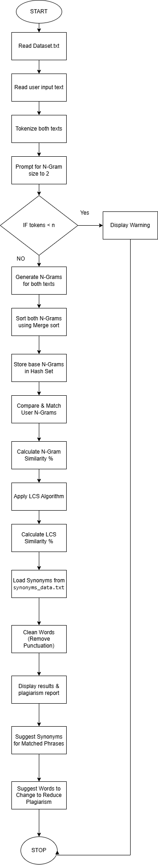

Sequence diagram
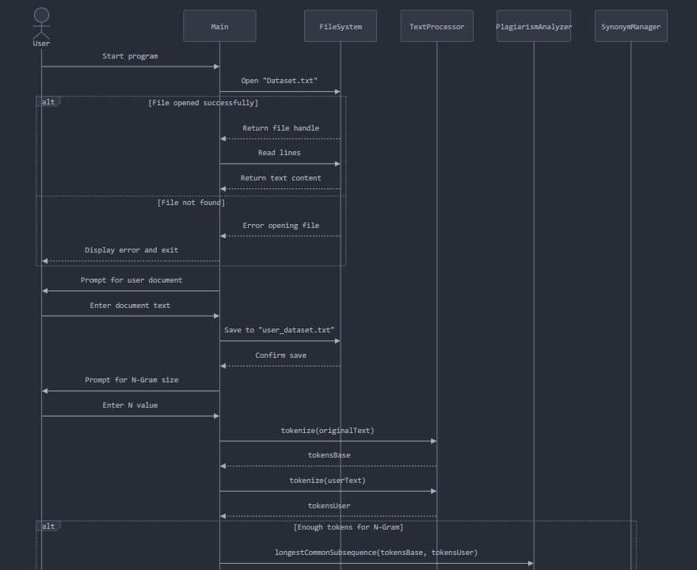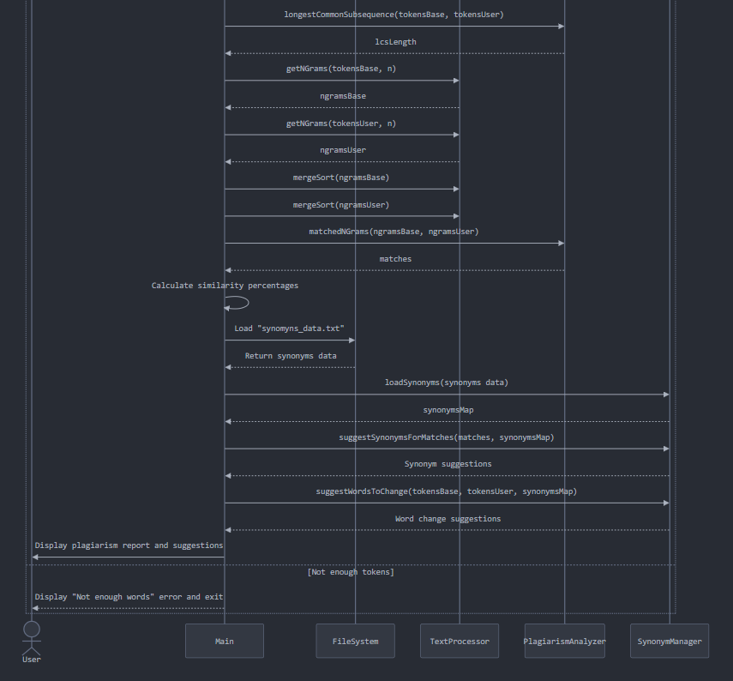

Code in C++
#include <iostream>
#include <fstream>
#include <sstream>
#include <vector>
#include <string>
#include <unordered_set>
#include <unordered_map>
#include <algorithm>
using namespace std;
// Tokenizer
vector<string> tokenize(string str) {
vector<string> tokens;
string token;
stringstream ss(str);
while (ss >> token) {
tokens.push_back(token);
}
return tokens;
}
// LCS (Dynamic Programming)
int longestCommonSubsequence(vector<string>& a, vector<string>& b) {
int m = a.size(), n = b.size();
vector<vector<int>> dp(m+1, vector<int>(n+1, 0));
for (int i = 1; i <= m; ++i)
for (int j = 1; j <= n; ++j)
if (a[i-1] == b[j-1])
dp[i][j] = dp[i-1][j-1] + 1;
else
dp[i][j] = max(dp[i-1][j], dp[i][j-1]);
return dp[m][n];
}
// N-Grams
vector<string> getNGrams(vector<string>& tokens, int n) {
vector<string> ngrams;
if (tokens.size() < n) return ngrams;
for (size_t i = 0; i <= tokens.size() - n; ++i) {
string ngram = "";
for (int j = 0; j < n; ++j) {
ngram += tokens[i + j];
if (j < n - 1) ngram += " ";
}
ngrams.push_back(ngram);
}
return ngrams;
}
// Merge Sort for N-Grams
void merge(vector<string>& arr, int l, int m, int r) {
int n1 = m - l + 1;
int n2 = r - m;
vector<string> L(arr.begin() + l, arr.begin() + m + 1);
vector<string> R(arr.begin() + m + 1, arr.begin() + r + 1);
int i = 0, j = 0, k = l;
while (i < n1 && j < n2) {
if (L[i] <= R[j]) arr[k++] = L[i++];
else arr[k++] = R[j++];
}
while (i < n1) arr[k++] = L[i++];
while (j < n2) arr[k++] = R[j++];
}
void mergeSort(vector<string>& arr, int l, int r) {
if (l < r) {
int m = l + (r - l)/2;
mergeSort(arr, l, m);
mergeSort(arr, m+1, r);
merge(arr, l, m, r);
}
}
// Compare N-Grams
vector<string> matchedNGrams(vector<string>& base, vector<string>& user) {
unordered_set<string> baseSet(base.begin(), base.end());
vector<string> matches;
for (const string& gram : user) {
if (baseSet.find(gram) != baseSet.end()) {
matches.push_back(gram);
}
}
return matches;
}
// NEW FUNCTIONS BEGIN HERE
// Function to load synonyms data from file - updated for colon delimiter
unordered_map<string, vector<string>> loadSynonyms(const string& filename) {
unordered_map<string, vector<string>> synonymsMap;
ifstream file(filename);
if (!file.is_open()) {
cerr << "Error opening " << filename << endl;
return synonymsMap;
}
string line;
while (getline(file, line)) {
size_t colonPos = line.find(':');
if (colonPos != string::npos) {
// Extract the key word (before the colon)
string word = line.substr(0, colonPos);

// Remove trailing spaces from the word
word.erase(word.find_last_not_of(" \t") + 1);

// Extract the synonyms part (after the colon)
string synonymsStr = line.substr(colonPos + 1);

// Parse synonyms
vector<string> synonymsList;
istringstream synStream(synonymsStr);
string synonym;

while (synStream >> synonym) {
// Remove comma if it exists
if (synonym.back() == ',') {
synonym.pop_back();
}
synonymsList.push_back(synonym);
}

synonymsMap[word] = synonymsList;
}
}

file.close();
return synonymsMap;
}

// Function to clean a word (remove punctuation for matching)
string cleanWord(const string& word) {
string cleaned = word;
// Remove common punctuation
for (char& c : cleaned) {
if (ispunct(c)) {
c = ' ';
}
}
// Remove extra spaces
stringstream ss(cleaned);
ss >> cleaned;
return cleaned;
}

// Function to suggest synonyms for words in matched phrases
void suggestSynonymsForMatches(const vector<string>& matches, const
unordered_map<string, vector<string>>& synonymsMap) {
cout << "\n----- Synonym Suggestions for Matched Phrases -----\n";

for (const string& match : matches) {
cout << "For phrase: \"" << match << "\"" << endl;

// Tokenize the matched phrase
vector<string> words = tokenize(match);
bool hasSuggestions = false;

for (const string& word : words) {
// Clean the word and convert to lowercase for matching
string cleanedWord = cleanWord(word);
transform(cleanedWord.begin(), cleanedWord.end(), cleanedWord.begin(), ::tolower);

// Check if we have synonyms for this word
auto it = synonymsMap.find(cleanedWord);
if (it != synonymsMap.end() && !it->second.empty()) {
hasSuggestions = true;
cout << " Instead of \"" << word << "\", consider: ";
for (size_t i = 0; i < it->second.size(); ++i) {
cout << it->second[i];
if (i < it->second.size() - 1) {
cout << ", ";
}
}
cout << endl;
}
}

if (!hasSuggestions) {
cout << " No synonyms found for words in this phrase." << endl;
}
cout << endl;
}
}

// Function to find words that contribute most to plagiarism
void suggestWordsToChange(const vector<string>& tokensBase, const vector<string>&
tokensUser,
const unordered_map<string, vector<string>>& synonymsMap) {
cout << "\n----- Words to Change to Reduce Plagiarism -----\n";

// Count word frequencies in the base text
unordered_map<string, int> baseFreq;
for (const string& word : tokensBase) {
string cleanedWord = cleanWord(word);
transform(cleanedWord.begin(), cleanedWord.end(), cleanedWord.begin(), ::tolower);
if (!cleanedWord.empty()) {
baseFreq[cleanedWord]++;
}
}

// Count which words from user text also appear in base text
unordered_map<string, int> commonWords;
unordered_map<string, string> originalForm; // To keep original casing

for (const string& word : tokensUser) {
string cleanedWord = cleanWord(word);
transform(cleanedWord.begin(), cleanedWord.end(), cleanedWord.begin(), ::tolower);

if (!cleanedWord.empty() && baseFreq.find(cleanedWord) != baseFreq.end()) {
commonWords[cleanedWord]++;
// Keep the original form for display
if (originalForm.find(cleanedWord) == originalForm.end()) {
originalForm[cleanedWord] = word;
}
}
}

// Sort words by frequency (most common first)
vector<pair<string, int>> sortedCommon(commonWords.begin(), commonWords.end());
sort(sortedCommon.begin(), sortedCommon.end(),
[](const pair<string, int>& a, const pair<string, int>& b) {
return a.second > b.second;
});

// Display top words to change (up to 10)
int count = 0;
for (const auto& pair : sortedCommon) {
if (count >= 10) break;

auto it = synonymsMap.find(pair.first);
if (it != synonymsMap.end() && !it->second.empty()) {
string displayWord = originalForm[pair.first];
cout << "The word \"" << displayWord << "\" appears " << pair.second
<< " times and could be replaced with: ";

for (size_t i = 0; i < it->second.size(); ++i) {
cout << it->second[i];
if (i < it->second.size() - 1) {
cout << ", ";
}
}
cout << endl;
count++;
}
}

if (count == 0) {
cout << "No common words with available synonyms found." << endl;
}
}
// Main
int main() {
string originalText, userText, line;

// Read base file
ifstream baseFile("Dataset.txt");
if (!baseFile.is_open()) {
cerr << "Error opening Dataset.txt\n";
return 1;
}
while (getline(baseFile, line)) {
originalText += line + " ";
}
baseFile.close();

// Take user document input
cout << "Paste Your content:\n";
getline(cin, userText);
ofstream userFile("user_dataset.txt");
userFile << userText;
userFile.close();
cout << "User input saved to user_dataset.txt\n";

// Get N-Gram size
int n = 2;
/* cout << "Enter N-Gram Size: ";
cin >> n;
cin.ignore();*/

// Tokenization
vector<string> tokensBase = tokenize(originalText);
vector<string> tokensUser = tokenize(userText);
if (tokensUser.size() < n || tokensBase.size() < n) {
cout << "\nNot enough words for the selected N-Gram size.\n";
return 1;
}

// LCS Check
int lcsLength = longestCommonSubsequence(tokensBase, tokensUser);
double lcsPercent = (double)lcsLength / tokensUser.size() * 100.0;

// N-Gram Check
vector<string> ngramsBase = getNGrams(tokensBase, n);
vector<string> ngramsUser = getNGrams(tokensUser, n);
mergeSort(ngramsBase, 0, ngramsBase.size() - 1);
mergeSort(ngramsUser, 0, ngramsUser.size() - 1);
vector<string> matches = matchedNGrams(ngramsBase, ngramsUser);
double ngramPercent = (double)matches.size() / ngramsUser.size() * 100.0;

// Final Output
cout << "\n----- Plagiarism Report -----\n";
cout << "Similarity: " << lcsPercent << "%\n";
// cout << "N-Gram Similarity: " << ngramPercent << "%\n";

/*cout << "\nMatched Phrases:\n";
for (const auto& phrase : matches) {
cout << "- " << phrase << "\n";
}*/

// NEW CODE: Load synonyms and provide suggestions
unordered_map<string, vector<string>> synonymsMap =
loadSynonyms("synomyns_data.txt");

// Suggest synonyms for matched phrases
suggestSynonymsForMatches(matches, synonymsMap);

// Suggest words to change to reduce plagiarism
suggestWordsToChange(tokensBase, tokensUser, synonymsMap);
return 0;
}

Output Screenshot
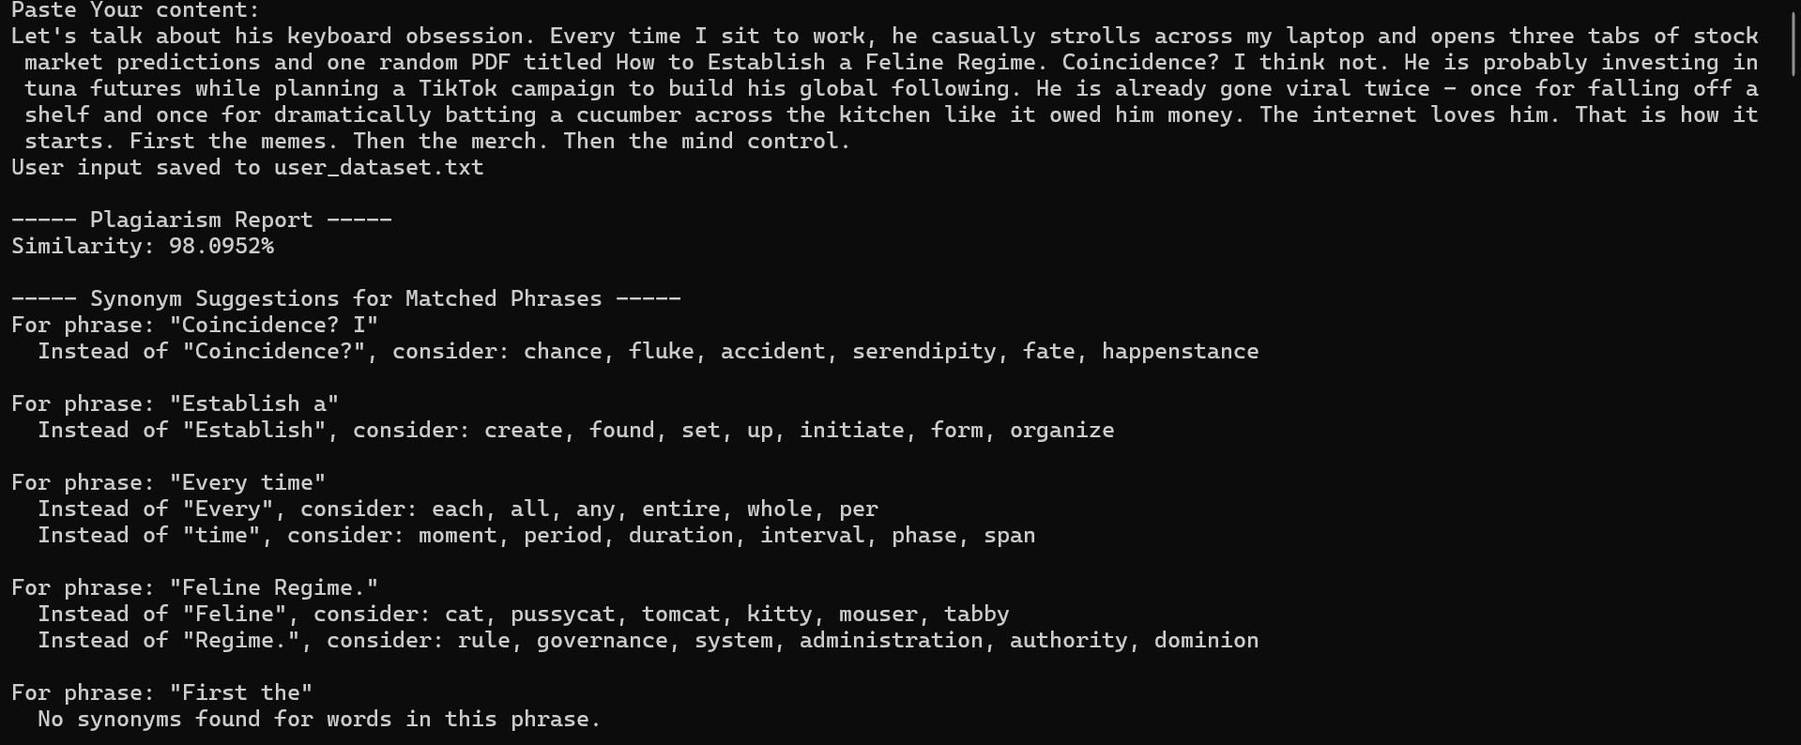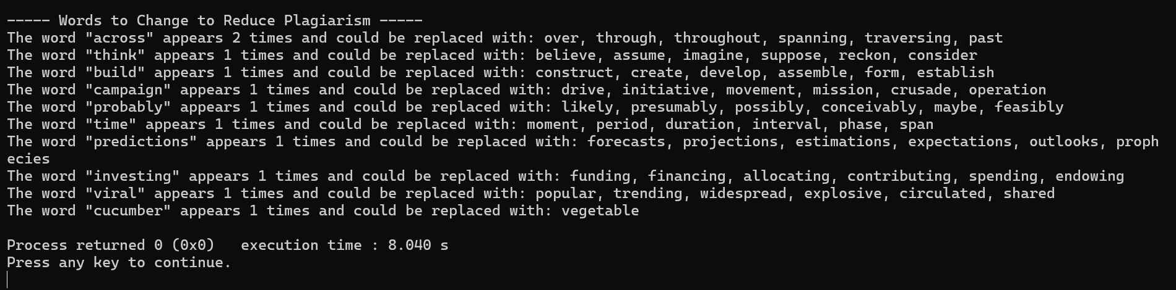
Dataset for storing synonyms (synomyns_data.txt)

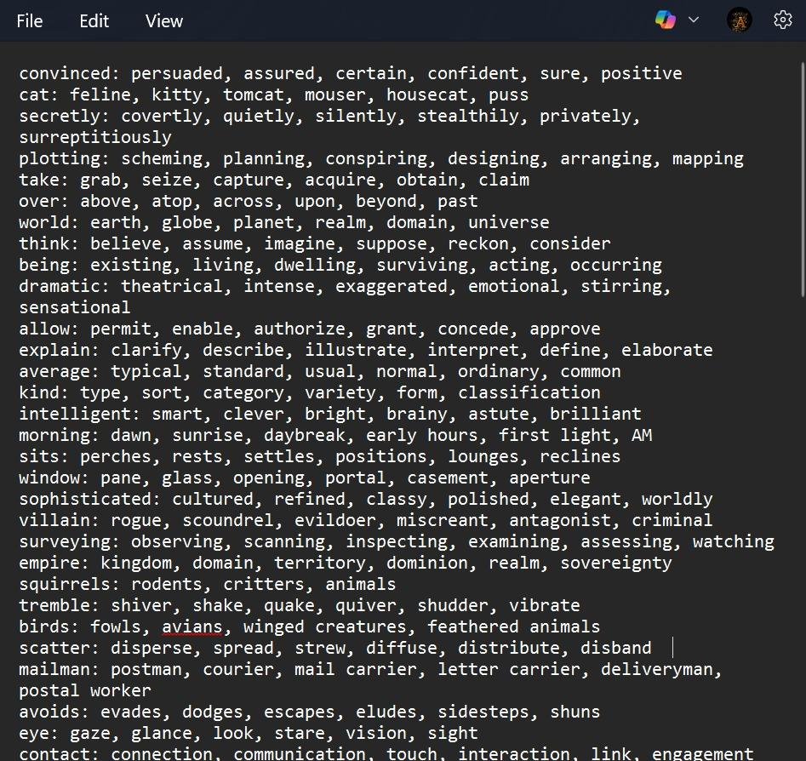
Dataset for storing original text (Dataset.txt)

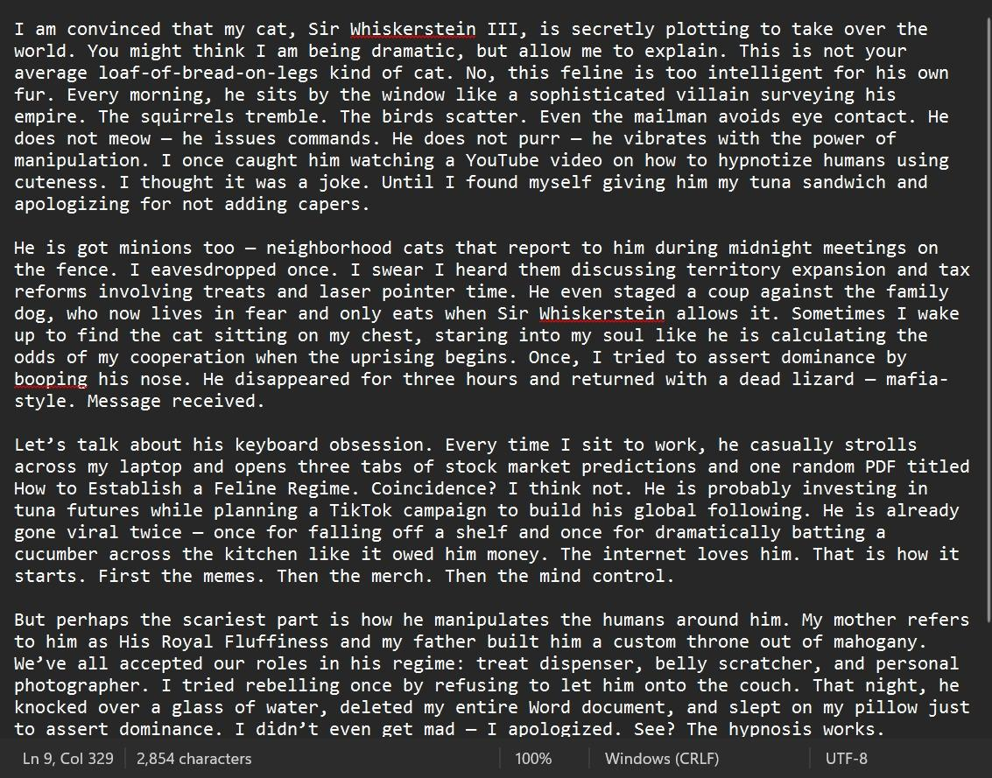

Dataset for storing user input text (user_dataset.txt)

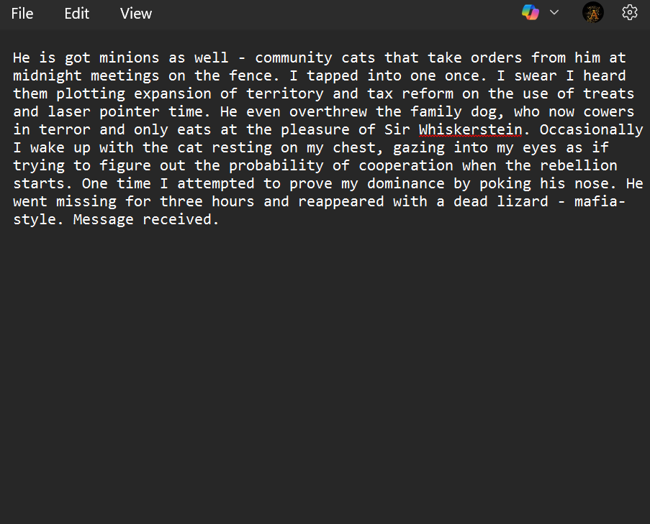
(This is a sample output of how user input is stored in the Dataset )

Time and Space Complexity Analysis
Understanding the Variables:
- B = Number of words in the base text (e.g., original article or reference document).
- U = Number of words in the user input (e.g., student's submission).
- S = Number of synonym entries (from a database like WordNet).
- M = Number of matched phrases (used when suggesting synonyms or alternatives).
Step-by-Step Breakdown:
- O(B + U) – Tokenization:
Breaking both texts into individual words (tokens) requires scanning each word once, so it's linear in both B and U.
- O(B * U) – LCS (Longest Common Subsequence):
This algorithm compares the sequences of words in both texts to find the longest matching pattern. It's a quadratic operation in the worst case, making it one of the dominant terms.
- O(B + U) – N-Grams:
Generates chunks of n consecutive words. Like tokenization, it's a linear pass over the word lists.
- O(B log B + U log U) – Merge Sort:
Used to sort tokens (e.g., for efficient matching or duplicate removal). Sorting takes log time per item, so this term also becomes dominant for large inputs.
- O(B + U) – Matching:
Once sorted, matching words between texts can be done linearly (like in merge sort’s merge step).
- O(S) – Load Synonyms:
Loading a synonym dataset (like WordNet), once per run, is linear in the size of the synonym list.
- O(M) – Synonym Suggestions:
For every matched phrase, synonyms are fetched or suggested, done once per match.
- O(U) – Word Suggestion:
Word-level suggestions for user input, scanning each word for alternatives.
Final Time Complexity: O(B * U + B log B + U log U + S + M)​
- O(B * U) is the most costly due to the nested comparison from LCS.
- O(B log B + U log U) from sorting is also significant, especially with large inputs.
- Other terms (like O(S) and O(M)) depend on data size and match count, but are generally manageable.

Limitations
- Scalability Issues
Not suitable for large-scale comparisons; lacks efficient data structures like hash maps or suffix trees.
- Limited File Format Support
Only supports .txt files; doesn't allow PDF, DOCX, or image uploads.
- No OCR Functionality
Cannot extract text from scanned documents or images; lacks Optical Character Recognition.
- No Real-time Detection
Works offline and only on uploaded files; can't check plagiarism across the internet or live databases.
- No UI for Highlighting
Lacks a user-friendly interface to show which parts are plagiarized side by side.

Scope of Improvement
1. Semantic Analysis
Incorporating NLP-based semantic similarity helps detect cases where the content has been smartly paraphrased but retains the same meaning. Instead of just matching exact words, it understands context and intent, catching more sophisticated forms of plagiarism.
2. Synonym Detection (with high scalability)
Using tools like WordNet or pre-trained word embeddings (e.g., Word2Vec, GloVe) allows the system to recognize synonyms and similar expressions. This enhances detection accuracy when someone replaces words with similar meanings to avoid simple plagiarism checks.
3. GUI Integration
A graphical user interface (GUI) makes the tool user-friendly. Users can easily upload files and view results in a visual format, making the tool more accessible to non-technical users in schools, offices, or publishing houses.
4. Multilingual Support
Extending detection beyond English enables broader use. With language models or translation integration, the tool can handle documents in Hindi, Spanish, French, etc., making it useful in international settings.

5. Parallelism
Using multithreading speeds up the process by allowing multiple comparisons to run simultaneously. This is especially useful when scanning large document sets, improving performance and efficiency.
6. More Advanced Algorithms
- Rabin-Karp: A fast pattern-matching algorithm ideal for detecting exact sequences in text using hash functions.
- MinHash: Efficiently estimates similarity between large documents by comparing hashed values of content chunks.
- Cosine Similarity: Measures the angle between document vectors to detect similarity in meaning, even with different wording.

Conclusion
This project successfully develops a plagiarism checker using C++, integrating fundamental algorithms and data structures to analyze textual similarities. It leverages techniques such as string matching, tokenization, and synonym comparison which allows the system to effectively detect both direct and paraphrased plagiarism.
It also highlights the importance of optimizing for time and space complexity, especially when handling large datasets. Overall, this plagiarism checker serves as a foundational tool for content originality verification and can be further enhanced using Natural Language Processing (NLP) and machine learning techniques in future iterations.

References
Academic Papers and References on Plagiarism Detection
- "Detecting Text Similarity Using N-grams and LCS Methods"
  - Journal of Computing and Information Technology
  - https://cit.fer.hr/index.php/CIT/article/view/3317
- "A Survey of Text Similarity Approaches"
  - International Journal of Computer Applications
  - https://www.ijcaonline.org/archives/volume68/number13/11533-6899
- "N-gram-based Text Categorization"
  - University of Pennsylvania
  - http://citeseerx.ist.psu.edu/viewdoc/summary?doi=10.1.1.53.9367
Algorithm Implementation Resources
- "Dynamic Programming: Longest Common Subsequence"
  - GeeksForGeeks
  - https://www.geeksforgeeks.org/longest-common-subsequence-dp-4/
- "Merge Sort Algorithm"
  - Stanford University
  - https://stanford.edu/class/archive/cs/cs161/cs161.1168/lecture4.pdf
- "Efficient N-gram Implementation in C++"
  - Stack Overflow Discussion
  - https://stackoverflow.com/questions/13729752/n-gram-efficient-storage-retrieval
Data Structures Used in Your Code
- "C++ STL: Unordered Maps and Sets"
  - GeeksForGeeks
  - https://www.geeksforgeeks.org/unordered_map-in-cpp-stl/
- "Using Maps and Vectors in C++"
  - Microsoft C++ Documentation
  - https://learn.microsoft.com/en-us/cpp/standard-library/map-class
Synonym Replacement and Text Paraphrasing
- "Automated Paraphrasing for Plagiarism Detection"
  - ACM Digital Library
  - https://dl.acm.org/doi/10.1145/3209219.3209230
- "Text Paraphrasing for Natural Language Processing"
  - Journal of Artificial Intelligence Research
  - https://www.jair.org/index.php/jair/article/view/10856
Similar Systems and Implementations
- "MOSS: A System for Detecting Software Similarity"
  - Stanford University
https://theory.stanford.edu/~aiken/moss/
- "JPlag: Detecting Software Plagiarism"
  - GitHub Repository
https://github.com/jplag/jplag

